|  |  |  |  |  |  |  |
| --- | --- | --- | --- | --- | --- | --- |
| **S.NO** | PRODUCT NAME | YEAR STARTED | YEAR ENDED | REASON FOR FAILURE | USED FOR | THINGS TO FIX THE PRODUCT |
| 1. | Microsoft Zune | 2006 | 2012 | Poor marketing, strong iPod competition | Music player | Better marketing, unique features |
| 2. | Facebook Home | 2013 | 2014 | Poor user adoption, intrusive UI | Android launcher | Better UI, improved integration |
| 3. | Segway | 1999 | 2013 | High cost, limited practicality | Personal transportation | Lower cost, better adoption |

Task 1

Task 2

|  |  |  |  |  |
| --- | --- | --- | --- | --- |
| S.No | Application Domain | Complex Problem Identified | |  | | --- | |  |   Justification |
| 1 | Healthcare | |  | | --- | | Lack of access to affordable healthcare |  |  | | --- | |  | | Rising costs, shortage of medical professionals, and inefficiencies in healthcare systems. |
| 2 | Transportation | Traffic congestion in metropolitan cities | |  | | --- | |  |  |  | | --- | | Increasing vehicle numbers, inadequate public transport, and poor infrastructure planning. | |
| 3 | |  | | --- | |  |  |  | | --- | | Environment | | Plastic waste management | Non-biodegradable plastics causing pollution and harming marine life. |
| 4 | Education | Quality education in remote areas | Limited access to schools, lack of trained teachers, and poor internet connectivity. |

Task 3



|  |  |  |  |  |
| --- | --- | --- | --- | --- |
| **Product Features** | Current State | GAP | Future State | Action Plan |
| Network Coverage | |  | | --- | |  |   Delivery limited to major cities, slower in rural areas.   |  | | --- | |  | | Limited delivery reach affects customer satisfaction. | Fast and reliable delivery across urban and rural areas. | Expand logistics partnerships and warehouse network. |
| Data Speed & Quality | Website/app crashes during peak sales events. | High traffic overwhelms servers, leading to slow load times. | Smooth and responsive shopping experience during all seasons. | Upgrade cloud infrastructure, implement CDN and AI-based load balancing. |
| Customer Support | Slow response times, high volume of unresolved complaints. | Lack of automation and limited support channels | 24/7 efficient support across multiple platforms. | |  | | --- | |  |  |  | | --- | |  |   Introduce AI chatbots, train staff, and improve self-service options. |
| Pricing & Discounts | Inconsistent pricing and lack of transparency in deals. | Competitors offer better-structured and predictable discounts. | Simple, competitive pricing with transparent deals. | Implement AI-driven dynamic pricing and customer loyalty programs. |
| Payment Options | Limited local payment methods, delays in refunds. | Users face inconvenience due to lack of UPI and wallet options. | Seamless checkout with multiple payment choices. | Collaborate with payment gateways; enable instant refunds and flexible EMI options. |
| Product Availability | Stock-outs of popular items, poor inventory forecasting. | Lack of predictive analytics leads to demand-supply mismatches. | Real-time inventory updates with better stock management. | Use AI for demand forecasting, optimize supplier coordination. |
| Delivery Speed | Standard delivery takes 3-7 days for most locations | Competitors offer same-day/next-day delivery in more areas. | Fastest possible delivery with real-time tracking. | Expand fulfilment centres; introduce drone/express delivery services. |

#Task: 7 Gap Analysis for E-Commerce Platforms

#Task: 8

The Future of   IT in Electric Vehicles (EVs) and the Automobile Industry

The automobile industry is on the verge of being revolutionized, and driving this revolution at its helm is a marvelous force — Electric Vehicles, or EVs. In our journey towards a greener and cleaner world, the contribution of EVs to the automobile industry cannot be emphasized enough.

To begin with, let us marvel at how EVs are not a temporary success but here to stay. Fuel-guzzling conventional cars that run on ICE have been the transport king for more than a century. Yet, with the world struggling to cope with climate change, air pollution, and depleting fossil fuels, the transition towards cleaner alternatives is no longer a choice. Enter Electric Vehicles, which will help us wean ourselves off oil, reduce toxic emissions, and join the fight against climate change on earth.

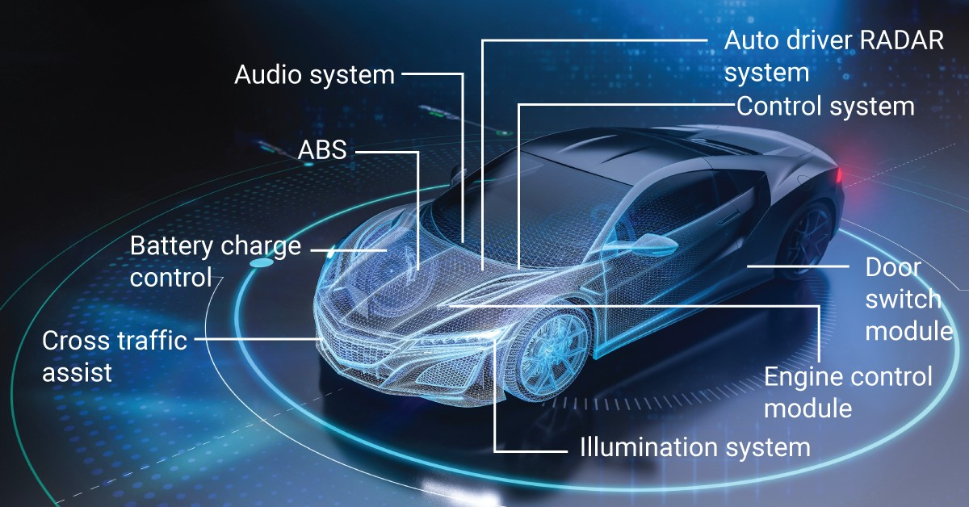

The drivers of EV growth are obvious. Governments everywhere are establishing tighter emission standards, at the same time providing incentives for the adoption of cleaner technology. Tax rebates, subsidies, and rebates on the sale of electric vehicles are already positively pricing EVs and making them accessible to common consumers. Additionally, the development in battery technology — particularly efforts being made on solid-state batteries — is not only making EVs an efficient source of energy but also affordable and with longer driving ranges.

But what's in the future for EVs? It is probable that in the next few decades, EVs will be the cars of choice on the roads. The support infrastructure — charging stations and improved grid integration — is evolving systematically. We are also witnessing the creation of ultra-fast charging technologies, which will reduce the time it takes to refuel a vehicle and make it as similar to filling up a gas car as possible.

Additionally, technological advancements in connectivity and autonomous driving will enable a whole new experience of driving. Imagine having autonomous electric vehicles on the road communicating with each other and making traffic flow more efficient, reducing congestion, and roads safer.

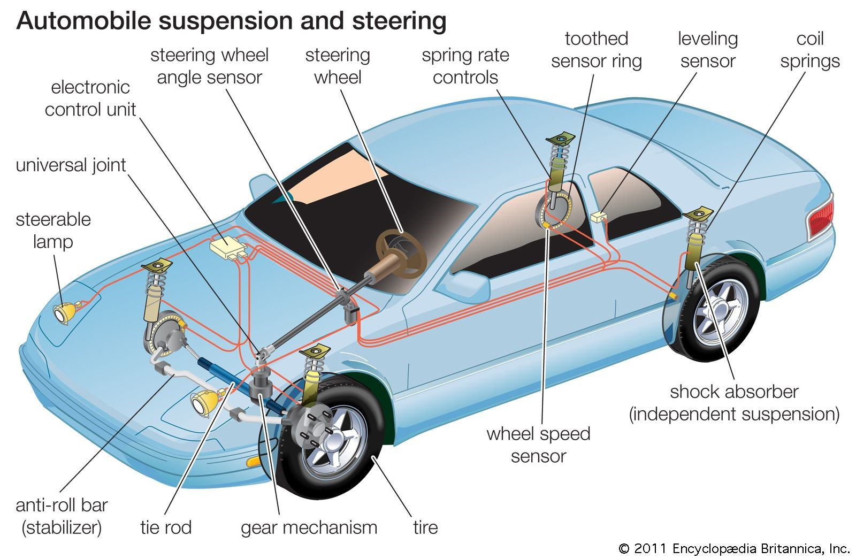

However, it is also significant to note that there are challenges. Producing and disposing lithium-ion batteries create environmental concerns, and it is essential to ensure that the energy used to charge EVs is derived from clean sources. In addition, electric car adoption requires massive investment in charging points, particularly for rural and poor communities.

However, electric vehicles have a very promising future. Players like Tesla, Rivian, and incumbent automotive players like General Motors, Ford, and Volkswagen are all investing heavily in EV technology. Electrification is no longer an "if" but a "when." In addition, when that "when" comes, the automobile industry will not only be cleaner but also smarter and more efficient.

Finally, the future of Electric Vehicles in the automotive market is promising. With technology advancing and growing demand from consumers, EVs will become the very core of our daily existence. This revolution will not only change the manner in which we drive but also redefine how we perceive transportation itself. The path to a greener, cleaner, and more sustainable tomorrow is being paved by the EV revolution, and it is a thrill for us all to be a part of.

The Future of IT in Avionics in the Aviation Industry

Avionics, or aviation electronics, is the backbone of modern air transport. It is an integral part of the systems that make modern aircraft not only functional but also highly efficient, secure, and reliable. But if we talk about the future of avionics, then we are actually talking about the future of aviation in general, because avionics keeps evolving and dictating how we fly.

At its core, avionics includes it all from communications equipment, navigation tools, and flight control systems, to weather radar, flight management systems, and cockpits displays. They all exist in concert to enhance the safety, smoothness, and efficiency of flight. However, the world of aviation, like any other industry, never stays the same. While we move towards the future, avionics is undergoing some essential changes.

Let us start first with automation. Previously, the cockpit would be cluttered with instruments to be monitored continuously and manually adjusted by pilots. But with present-day advanced avionics, automation is increasingly becoming a bigger contributor. Nowadays, modern airplanes are increasingly equipped with semi-autonomous flight-enabling systems. The age-old dream of total autonomy for aircraft, where pilots are only in supervisory roles, is now a reality and not a dream. In fact, companies like Boeing and Airbus already have their stakes in research and development of autonomous flight systems and unmanned aerial vehicles (UAVs). While there are still challenges, particularly in regulatory approval and maintaining safety, we are moving towards a day when autonomous flights might be a standard part of our skies.

Another area that is developing very quickly is communication. Traditionally, communications between aircraft and air traffic control have been voice communications via radio signals. However, as air travel becomes more popular, so does the need to control the skies more complexly. More modern systems such as Data Link Communication are offering pilots and controllers the capacity to transmit and receive messages digitally, which means clearer and faster communication. This change will help to minimize human error, improve situational awareness, and ultimately enhance air traffic capacity while ensuring safety.

Lastly, let us discuss next-generation navigation and GPS. The future of avionics will be dominated by even more precise and dependable navigation technologies. The most significant innovation among them is Satellite-Based Augmentation Systems (SBAS), which will significantly improve the accuracy of GPS navigation so that aircraft will be able to make more efficient and safer flights, particularly where traditional ground-based navigation aids are unavailable. This will allow aircraft to make flight paths with greater flexibility, which will save fuel, flight duration, and total environmental impact.

Besides, enhanced weather detection is changing the manner in which we anticipate and avoid dangerous weather formations. Weather radar and forecasting units, integrated into avionics, will improve further with machine learning codes to provide real-time, hyper-precise weather intelligence to pilots. This system can forecast turbulence, storms, or lightning strikes with ample warning time and equip pilots with enhanced decision-support tools for improving passenger safety and comfort.

The push towards sustainability is also a key driver in the avionics future. One of the largest carbon-emitting industries, there is a growing need to design energy-efficient flight systems. This varies from avionics that optimize flight routes to conserve fuel, monitor engine performance for peak efficiency, and even systems that aid in the development of hybrid or all-electric aircraft.

Subsequently, although much is ahead for the future, there are setbacks to be bridged. One such prominent setback is cybersecurity. As avionics systems become more integrated and reliant on digital communication, so does the risk of cyberattack. Ensuring that aircraft systems are invulnerable to hackers and technical malfunctions is imperative. In this regard, more focus is being put into designing more robust and secure systems to protect aircraft and flight operations from any possible breach.

Additionally, there is brought about by the new technologies the requirement for frequent training. The pilots and the engineers must ensure their knowledge stays current with respect to the constantly evolving systems of the cockpit. AR/VR avionics-based training devices will be critical in ensuring the next generation avionics specialists are properly prepared to handle the next-generation avionics equipment they will deal with.

In conclusion, the future of avionics in aviation is exciting, thrilling, and full of potential. Automation, advanced communication, navigation, and weather systems, and initiatives to reduce environmental impact and increase safety will all contribute to making flight more efficient, secure, and environmentally friendly. As avionics continues to develop, it will shape how we experience flight, making aviation a smoother, safer, and more intelligent means of transport.

Task 10 Article Reference and Inference Report

Preparation

Article Reference and Inference Report requires reading an article, determining central themes or concepts, referencing the article by citing particular sections of the article, and making inferences or conclusions based on what is read. Below is a step-by-step guide to preparing such a report:-

1. Understand the Objective of the Report:-

The report should provide a structured examination of an article, summarizing its key points prior to drawing inferences from the given information.

The report should be brief, clear, and reflect comprehension of the article's content, as well as analysis with insight.

1. Read the Article Carefully:-

Carefully read the article in an effort to comprehend its main ideas and arguments.

Read, taking down the principal sections with significant information, evidence, or data.

Take extra care to observe what the author's purpose of writing the article is, what arguments are presented, and the author's conclusion.

1. Identify Key Points and Themes:-

Main Argument What is the main argument or theme of the article?

Supporting Evidence: What evidence or data does the author provide to support their argument?

Conclusion-:

What does the author conclude at the end of the article?

1. Make Notes of Specific References:-
   * While you read, mark off items, quotes, or points of interest to the article that are most relevant. Those sources will be ,quoting directly, or paraphrased pieces of information that provide evidence to help support your analysis.
   * For example, when you quote a particular argument within the article, you should identify where you can find it (e.g., "the placement on page 5").
2. Formulate Inferences:-
   * As you read the article, make inferences or conclusions. Inferences are reasonable meanings or assumptions that you make from the information the article provides.
     + These inferences can be:
       - What the implications of the results in the article may be
       - What may occur according to the information the article provides
   * The broader meaning of the findings of the article
   * Connections of the article with recent trends, situation, or situations

Example Inference: - Should the article have been regarding renewable energy growth within rural towns, you could imply that renewable energy infrastructure development on a wider scale would support addressing energy poverty levels in those localities.

Typical Article Reference and Inference Report structure would entail the following subsections:

1. Title of the Report
   * A concise title that reflects the content of the report.
2. Introduction: -
   * Briefly introduce the article, mentioning its title, author, and the main subject matter.
   * State the purpose of your report (summarizing the article and making inferences).
3. Summary of the Article

Key Points: - Summarize the main themes, points, and facts discussed in the article.

* Make use of references to specific areas or quotes within the article. This provides credibility and allows the reader to check out the statements that you provide.

1. Inferences Based on the Article

Inferences: - What can be deduced or presumed from the information within the article?

* Explain how the article's findings have broader implications.
* Provide thoughtful, evidence-based comments on the applicability of the article to current issues or directions for the future.

